Question: What is the relationship between Normal Distribution and Probability distribution? are they both same?

Yes, Normal distribution and Probability distribution are same. In fact, normal distribution is a type of continuous probability distribution.

Let’s look at what is Probability distribution and Normal distribution.

[**Probability**](https://machinelearningmastery.com/what-is-probability/) can be used for more than calculating the likelihood of one event; it can summarize the likelihood of all possible outcomes.

**Probability distributions** indicate the likelihood of an event or outcome. A thing of interest in probability is called a random variable and probability distribution is a function that describes the likelihood of obtaining the possible values that a random variable can assume.

[Statisticians](https://statisticsbyjim.com/glossary/statistics/) use the following notation to describe probabilities:

p(x) = the likelihood that random variable takes a specific value of x.

The sum of all probabilities for all possible values must equal 1. Furthermore, the probability for a particular value or range of values must be between 0 and 1.

Probability distributions describe the dispersion of the values of a random variable. Consequently, the kind of variable determines the type of probability distribution. For a single random variable, [statisticians](https://statisticsbyjim.com/glossary/statistics/) divide distributions into the following two types:

* Discrete probability distributions for discrete variables
* Probability density functions for continuous variables

**Discrete probability distributions**

Discrete probability functions are also known as probability mass functions and can assume a discrete number of values. For example, coin tosses and counts of events are discrete functions. These are discrete distributions because there are no in-between values. For example, you can have only heads or tails in a coin toss.

For discrete probability distribution functions, each possible value has a non-zero likelihood. Furthermore, the probabilities for all possible values must sum to one. Because the total probability is 1, one of the values must occur for each opportunity.

For example, the likelihood of rolling a specific number on a die is 1/6. The total probability for all six values equals one. When you roll a die, you inevitably obtain one of the possible values

## Continuous Probability Distributions

Continuous probability functions are also known as probability density functions. You know that you have a continuous distribution if the variable can assume an infinite number of values between any two values. [Continuous variables](https://statisticsbyjim.com/glossary/continuous-variables/) are often measurements on a scale, such as height, weight, and temperature.

Unlike discrete probability distributions where each particular value has a non-zero likelihood, specific values in continuous distributions have a zero probability. For example, the likelihood of measuring a temperature that is exactly 32 degrees is zero.

Why? Consider that the temperature can be an infinite number of other temperatures that are infinitesimally higher or lower than 32. Statisticians say that an individual value has an infinitesimally small probability that is equivalent to zero.

Probabilities for continuous distributions are measured over ranges of values rather than single points. A probability indicates the likelihood that a value will fall within an interval.

**Normal distribution** is a probability function that describes how the values of a variable are distributed. It is a symmetric distribution where most of the observations cluster around the central peak and the probabilities for values further away from the [mean](https://statisticsbyjim.com/glossary/mean/) taper off equally in both directions. Extreme values in both tails of the distribution are similarly unlikely.

 The normal distribution has two parameters, the mean and standard deviation. The normal distribution does not have just one form. Instead, the shape changes based on the [parameter](https://statisticsbyjim.com/glossary/parameter/) values, as shown in the graphs below.

### **Mean**

The mean is the central tendency of the distribution. It defines the location of the peak for normal distributions. Most values cluster around the mean.

### **Standard deviation**

The standard deviation is a measure of variability. It defines the width of the normal distribution. The standard deviation determines how far away from the mean the values tend to fall. It represents the typical distance between the observations and the average.

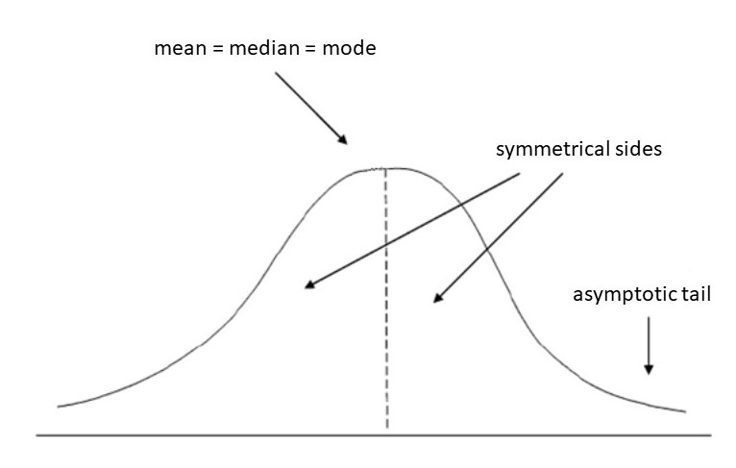

All forms of the normal distribution have the following characteristic properties.

* They’re all symmetric. The normal distribution cannot model [skewed](https://statisticsbyjim.com/glossary/skewed-data/) distributions.
* The mean, [median](https://statisticsbyjim.com/glossary/median/), and [mode](https://statisticsbyjim.com/glossary/mode/) are all equal.
* Half of the population is less than the mean and half is greater than the mean.
* The Empirical Rule allows you to determine the proportion of values that fall within certain distances from the mean. More on this below!

## The Empirical Rule for the Normal Distribution

When you have normally distributed data, the standard deviation becomes particularly valuable. You can use it to determine the proportion of the values that fall within a specified number of standard deviations from the mean. For example, in a normal distribution, 68% of the observations fall within +/- 1 standard deviation from the mean. This property is part of the Empirical Rule, which describes the percentage of the data that fall within specific numbers of standard deviations from the mean for bell-shaped curves.

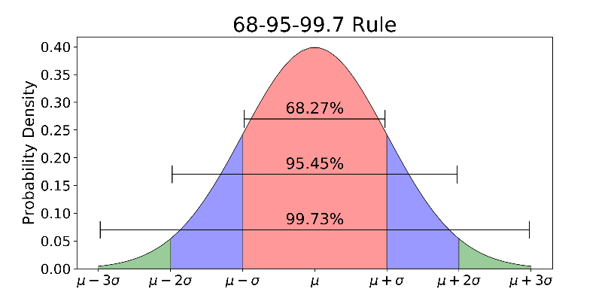

If a dataset follows a normal distribution, then about 68% of the observations will fall within  of the mean , which in this case is with the interval (-1,1). About 95% of the observations will fall within 2 standard deviations of the mean, which is the interval (-2,2) for the standard normal, and about 99.7% of the observations will fall within 3 standard deviations of the mean, which corresponds to the interval (-3,3) in this case.

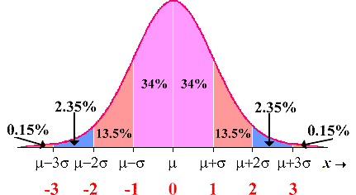

Probability distribution is a function that describes likelihood of obtaining the possible values that a random variable can assume. Normal distribution is a type of probability distribution used for describing how the values of a continuous variables are distributed.